Veeva Integrated Program GrandTest

Q4 :
- Create a rule to automatically assign a bug to a developer when the priority is set to highest.
- Write a query to find all unresolved bugs in a specific project, assign to a specific user Ex : Project=P1 and issuetype=Bug and status!=Done and assignee=currentUser()

- Create a rule to automatically assign a bug to a developer when the priority is set to highest.
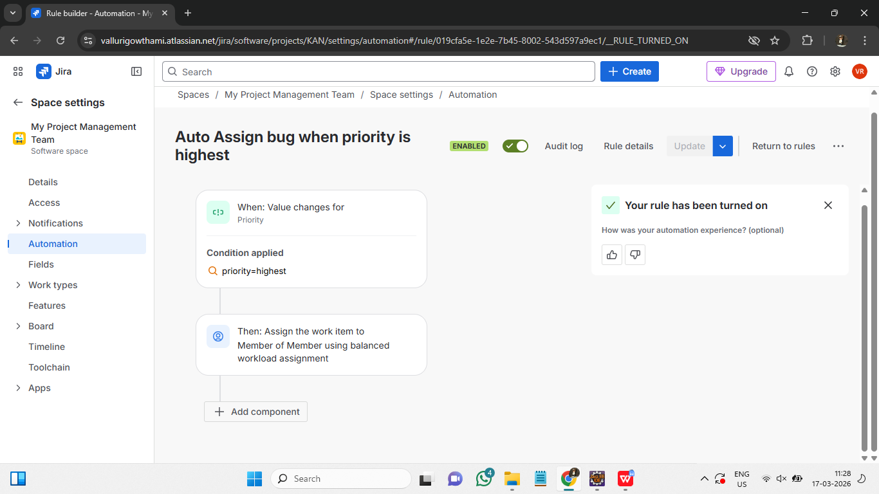
Steps to create rule to automatically assign a bug to a developer when the priority is set to highest:
- In jira, navigate to automation tab in a project space.
- Select create automation.
- Add triggers : Choose Field value changed and set priority as field. (This triggers when priority is updated)
- Then select THEN : Add an action
- Select assign work item and assign it to user in a role.
- Add JQL condition for issuetype=Bug. And assign it to member
- Finally click on turn on rule and add a title to it.

- Write a query to find all unresolved bugs in a specific project, assign to a specific user Ex : Project=P1 and issuetype=Bug and status!=Done and assignee=currentUser()
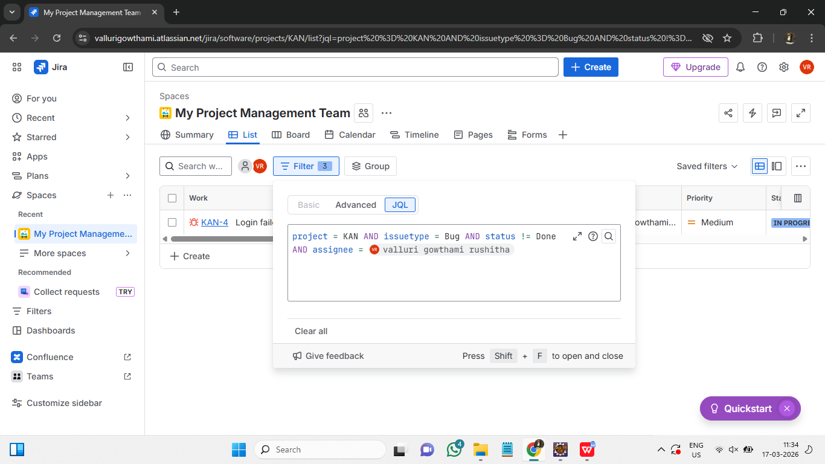
Steps to write a query to find all unresolved bugs in a specific project, assign to a specific user :
- In the project space in jira, Select filters and choose choose JQL.
- Write the below query in JQL tab:
Project=My Project Management Team and issuetype=Bug and status!=Done and assignee=valluri gowthami rushitha.
- Press Enter and it will show the filtered results according to the query.

